**Table of Contents**

**Report Task B1** 2

**1.** **Watch video tutorial on youtube:** 2

**2.** **Download both code and run it locally:** 2

**3.** **Setup github repository and commit all the code:** 3

**4.** **Basic understanding about the v0.1 code:** 3

**5.** **Challenges Faced & Problem-Solving:** 4

**6.** **Plan & Objectives for further step:** 4

# **Report Task B1**

# **Watch video tutorial on youtube:**

# **Download both code and run it locally:**

P1 Codebase when run done:

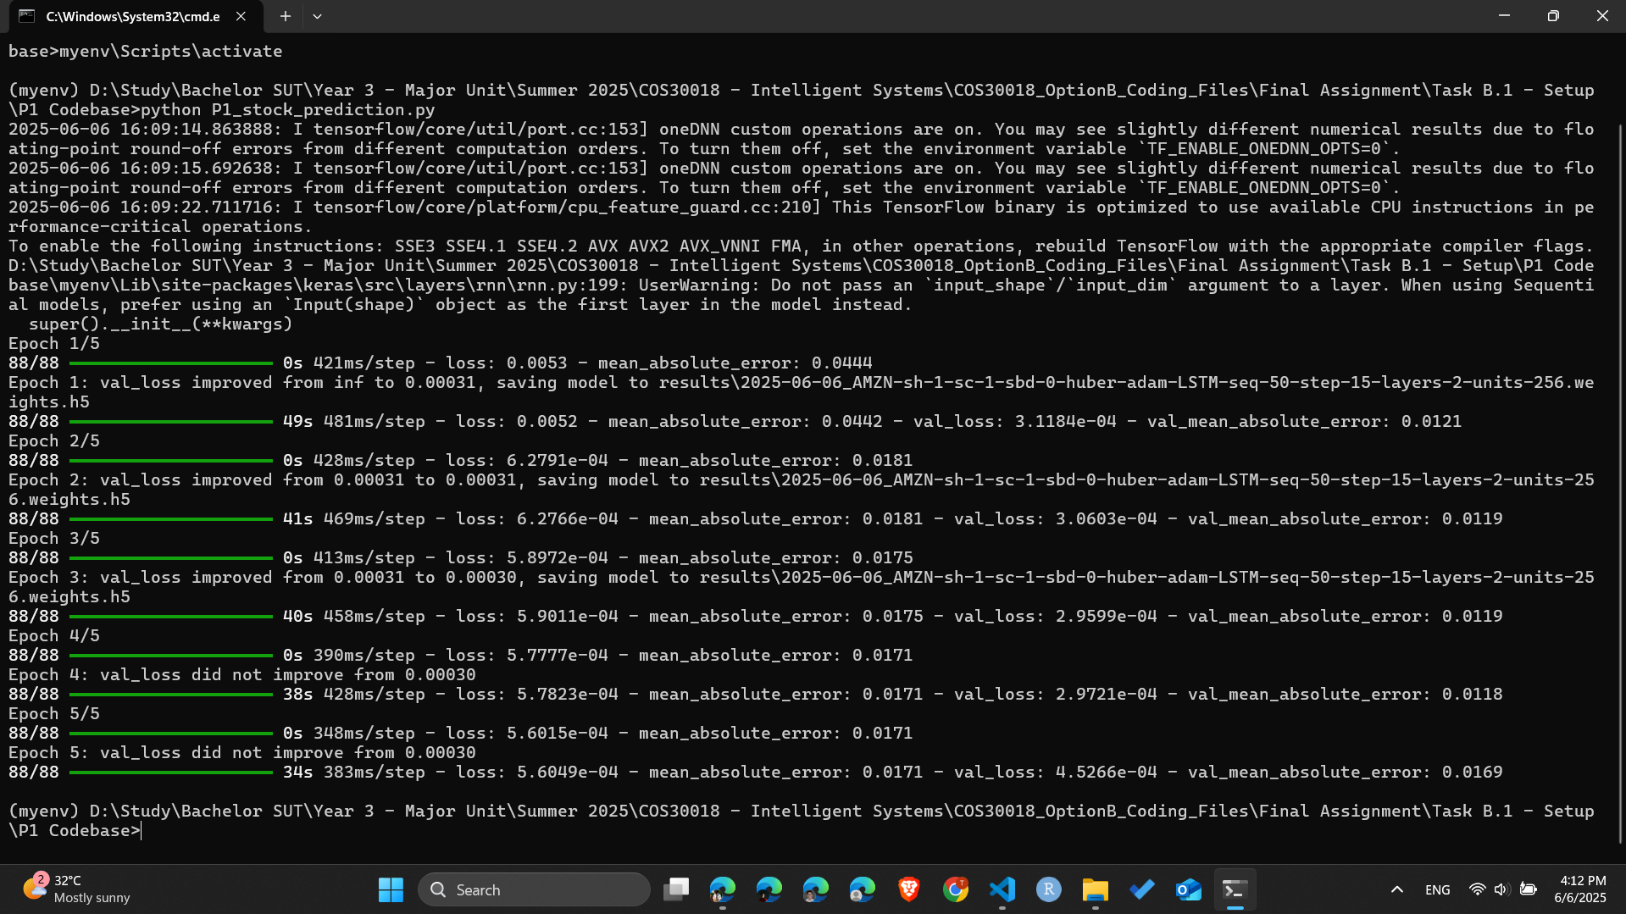

V0.1 Codebase:

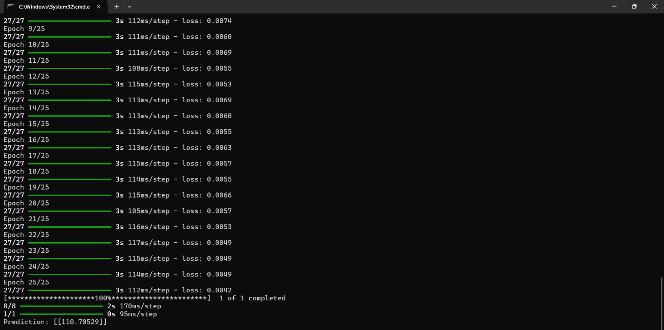

# **Setup github repository and commit all the code:**

This step is used to push all the code into the repository on github and for further enhancements on github. And adding a folder name Final Assignment which contain the weekly report file.

# **Basic understanding about the v0.1 code:**

**Here is the summary of workflow in 7 steps:**

1. **Data Loading**: Downloads historical stock data for training (2020–2023) and testing (2023–2024).
2. **Data Preparation**: Normalizes closing prices and creates 60-day sequences for training.
3. **Model Building**: Constructs a stacked LSTM model with dropout to prevent overfitting.
4. **Training**: Trains the model on the prepared data.
5. **Testing**: Prepares test data, makes predictions, and compares them to actual prices.
6. **Visualization**: Plots actual vs. predicted prices.
7. **Future Prediction**: Predicts the stock price for the next day.

* *Example:* "Linear Regression model achieved RMSE of $15.3 on validation set. Generated plot of actual vs. predicted prices."

# **Challenges Faced & Problem-Solving:**

For me this can be considered as take a new step into a new business domain with 0% knowledge about it. So at the initial, I started learning knowledge about economic stock,… to get familiar with it.

Another consideration is this is the first time that I get partaking about machine learning, deep learning and other related problem, so in another words a big vague vision for my huge picture about this assignment task,

Configuration also can be listed in due to the fact that I have never run a machine learning model locally. This take so much time to configure the code to let it run smoothly especially the code on Github.

# **Plan & Objectives for further step:**

On the next step, I am going to follow the guideline in each subtask to implement some feature about the code to upgrade the version of my code to get the best practice of it.

Along with the weekly presentation via video I will upload it on canvas and on youtube.